**Code**

**Assessing pulmonary function in 3-year-old children using respiratory oscillometry: a validation study in rural Guatemala**

Laura M. Grajeda, Keyla Castellanos, Tatiana Petrovick, Anaité Díaz-Artiga, Maria Reneé López, Albino Barraza-Villarreal, Lisa M. Thompson, Ye Shen, Jessica Knight, Luke P. Naeher, Thomas Clasen, Jennifer Peel, John P. McCracken, Eric D. McCollum

Contents

Goal: 1

Inputs: 1

Steps: 2

## Goal:

Perform quality control of oscillometry measurements collected with the Tremoflo C-100 Airwave Oscillometry System (THORASYS Thoracic Medical Systems, Montreal, Quebec, Canada) at 7 to 41 Hertz multifrequency range.

Quality control consists of:

1. Filter out incomplete breaths and breaths in which an upper airway artifact has been identified. A measurement must have at least 4 artifact-free breaths to be considered valid and usable.
2. Among the valid measurements, select the best ones and calculate test indices.

## Inputs:

Measurement data exported from the Tremoflo software:

1. Vol,Pcyl,Flow: The export contains volume, pressure, and flow signals collected every 0.004 seconds. An example of the file is shown below.

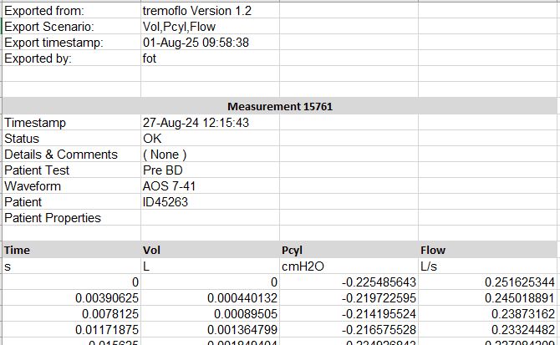

1. Timecourse Data: The export contains a time series of resistance and reactance endpoints calculated at each 0.1 seconds. An example of the file is shown below.

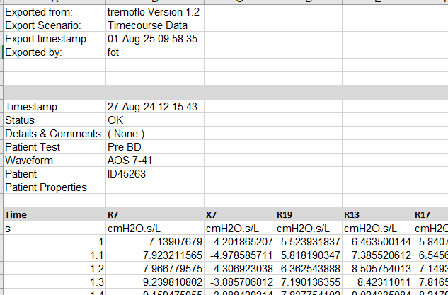

## Steps:

1. Extract the time, volume, pressure, and flow data that corresponds to an individual measurement from the “Vol,Pcyl,Flow” export.

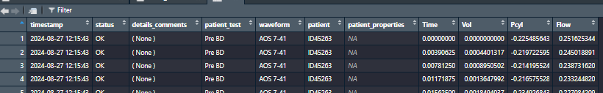

1. Extract the resistance and reactance data that correspond to an individual measurement from the “Timecourse Data” export.

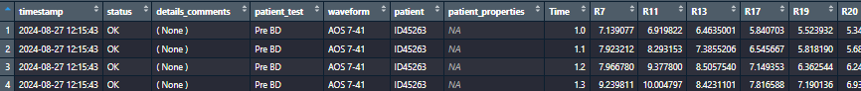

1. Apply the function “M.AllSteps()” on “Vol,Pcyl,Flow” and “Timecourse data”. This function uses other functions to:
   * Detect the start and end of all the breaths in the measurement
   * Trim the incomplete breaths and the start and end of the measurement
   * Remove periods that may not contain a breath
   * Apply functions to identify leaks
   * Apply functions to identify obstructions
   * Create an indicator variable as to whether the breath needs to be filtered out under each of the alternative artifact removal methods (AR1 or AR2)
   * Create an indicator variable as to whether the measure is valid (has more than 4 artifact-free breaths)

The output is a list containing two datasets, one for timecourse data and the other for Vol,Pcyl,Flow data. All the functions are defined in the file “Functions for artifact detection.Rmd”

1. Apply the function “M.AllPlots()” to create visualizations of the Z7, R7, X7, Flow, and Volume channels. Breaths colored in pink are to be filtered out according to the AR2 (SDExt) artifact removal method. The functions to create the plots are defined in the file “Functions for artifact detection.Rmd”

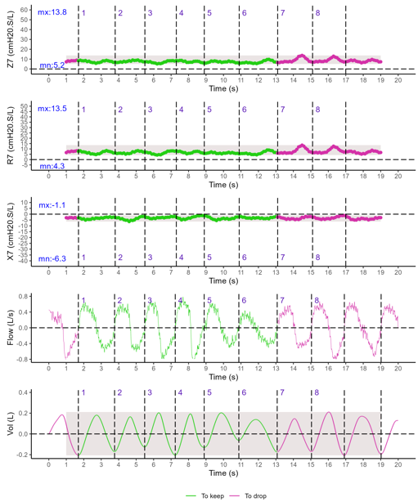

1. Rowbind all the measurements (Timecourse data) that belong to the same test.
2. Apply the function “T.AllSteps()” on binded Timecourse data. This function uses other functions to detect artifacts, similar to M.AllSteps(), but at the test level. The output will have an indicator variable to indicate whether each breath should be filtered out according to AR3 (TSDExt), and an indicator variable to indicate whether the measurement is valid (has more than 4 artifact-free breaths) under AR3 (TSDExt).